**MATRIX KEYPAD**

**What is Matrix Keypad?**

A matrix keypad is a small keypad which is used to take input from users.

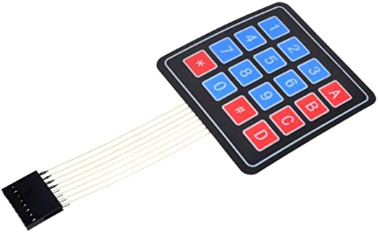

**How Matrix Keypad works?**

Below the top membrane of matrix keypad, there exist array of switches which are interconnected(see the figure below).

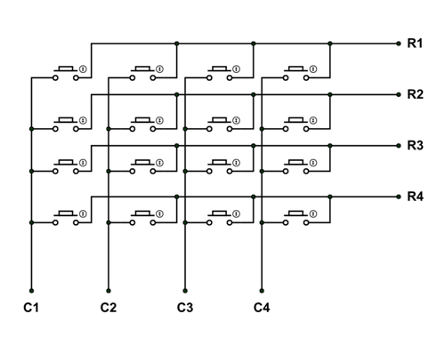

Now, there are 8 pins (4 row pins and 4 column pins) for a 4x4 keypad which are connected to the microcontroller. Now, 4 row pins are set to output and 4 column pins are set to input (vice versa can also be done). Now, a row line is selected and made high. Same is done with all the row lines in a loop at a very fast rate. Now, when a button is pressed, the current will now flow through column lines(as shown in figure below), and the microcontroller will detect a high in column line. Using this, the microcontroller can find the button from which column is selected and by finding the intersection with the row which was high at that moment, it determines the button pressed. When we actually use Matrix Keypad, we do not have to implement this in our code because the library **Keypad.h** makes things easy for us.

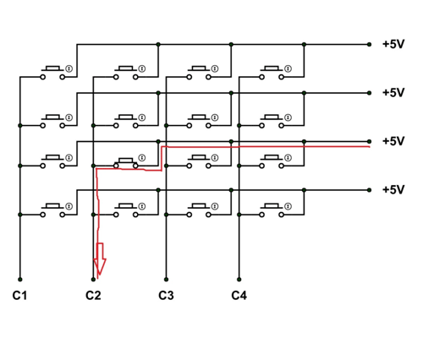

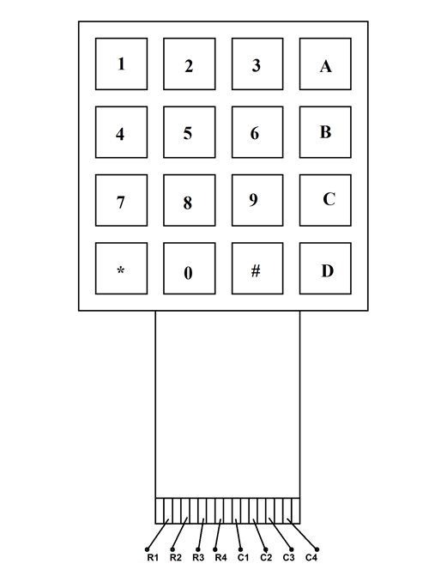**PINOUTs**

|  |  |
| --- | --- |
| **PIN NUMBER** | **DESCRIPTION** |
| R1 | It is taken from 1st Row. |
| R2 | It is taken from 2nd Row. |
| R3 | It is taken from 3rd Row. |
| R4 | It is taken from 4th Row. |
| C1 | It is taken from 1st Column. |
| C2 | It is taken from 2nd Column. |
| C3 | It is taken from 3rd Column. |
| C4 | It is taken from 4th Column. |

**Some More Specifications**

|  |  |
| --- | --- |
| Operating Voltage | +24V DC |
| Operating Current | 30 mA |
| Operating Temperature | 0-50°C |